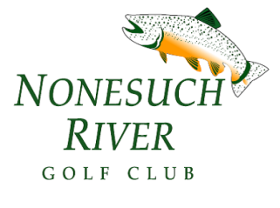
2021 Nonesuch River Golf Club
Junior Clinic Registration Form

Child’s Name _______________________________________ Age:___________

Parent (s) Contact Info below:

Phone _________________________ Email ______________________________

Phone _________________________ Email ______________________________

Please list any medical conditions or special considerations that we should know about such as asthma, allergies, previous injury, etc.
___________________________________________________________________
___________________________________________________________________
Does your child have his/her own set of clubs? Yes No

Please select the session in which you would to attend:

Session One
Mon. June 21st – Thurs. June 24th 9:00 – 11:00AM

Session Two
Mon. July 12th – Thurs. July 15th 9:00 – 11:00AM

The cost per student per session is $175^{.00}
Checks can be made out to Nonesuch River Golf Club

